La covarianza es una medida de dispersión conjunta de dos variables estadísticas.
- Si S_{xy} > 0 hay dependencia directa (positiva), es decir, a grandes valores de x corresponden grandes valores de y.
- Si S_{xy} = 0 Una covarianza 0 se interpreta como la no existencia de una relación lineal entre las dos variables estudiadas.
- Si S_{xy} < 0 hay dependencia inversa o negativa, es decir, a grandes valores de x corresponden pequeños valores de y.
Imagine that at one meeting of the Midwest Club of Poets a question arose whether people who like to read Gothic novels also like to read poetry. To resolve this, the club leader administered a short questionnaire to their members asking them to rate their liking of the Gothic novels (X) and poetry (Y). Responses from the subjects were recorded into the data matrix shown below

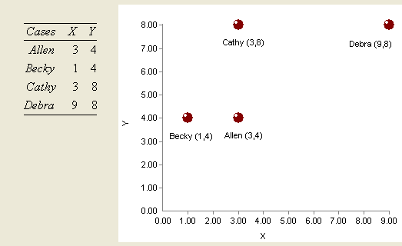

The question to be answered is whether the liking of the Gothic novels and poetry are related.

